OES Project Functional Specification Document
Author: Leif Liu
Last Updated: 2017-11-05

Document History
Date | Author | Summary of Change | Note
2017-11-03 | Leif Liu | Initialized version.
2017-11-04 | Leif Liu | Updated Use Case.
2017-11-05 | Leif Liu | Updated Use Case. | Finished
Overview 6
Use Case Diagrams 6
Use Case Scenarios 8
UC001 <SysAdmin Create User> 8
UC002 <SysAdmin Edit User> 10
UC003 <SysAdmin Delete User> 12
UC004 <SysAdmin View users list> 13
UC005 <ContentAdmin Create Question> 14
UC006 <ContentAdmin Delete Question> 14
UC007 <ContentAdmin Edit Question> 14
UC008 <ContentAdmin View questions list> 14
UC009 <ContentAdmin Create exam> 14
UC010 <ContentAdmin View exams list> 15
UC011 <Teacher View exams list> 15
UC012 <Student Check exams> 15
UC013 <SysAdmin Login&Logout> 15
UC014 <ContentAdmin Login&Logout> 16
UC015 <Teacher Login&Logout> 17
UC016 <Student Login&Logout> 17
UC017 <SysAdmin Edit user profile> 17
UC018 <ContentAdmin Edit user profile> 17
UC019 <Teacher Edit user profile> 17
UC020 <Student Edit user profile> 18
Non-functional Requirements 18
System Installation Requirements 18
Runtime Requirements 18
I18N and L10N Requirements 18
Documentation Requirements 18
Other Non-functional Requirement 18

Overview
We suppose to implement an online exam system which helps students take the exam and teachers review the exam results. The user with SysAdmin role can manage all users including create/edit/delete user. The user with ContentAdmin role can manage questions and create exam. Each user can access this system to edit his personal profile.

Use Case Diagrams

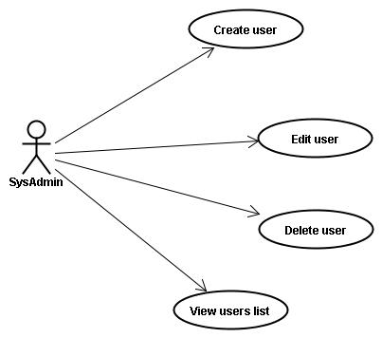
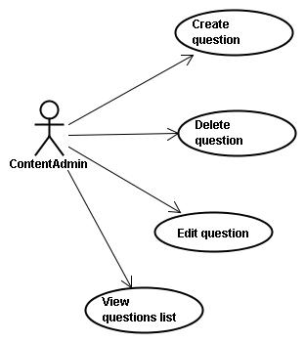

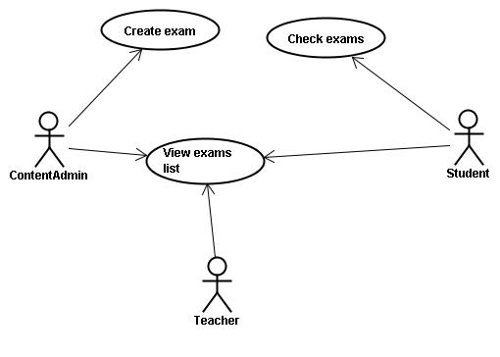

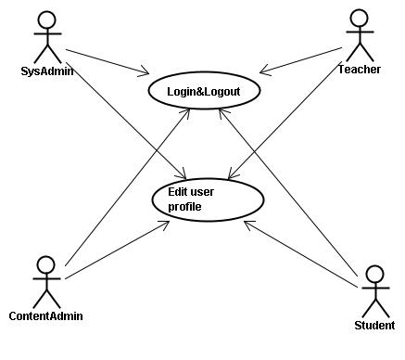

Use case id | Use case name
UC001 | SysAdmin Create User
UC002 | SysAdmin Edit User
UC003 | SysAdmin Delete User
UC004 | SysAdmin View users list
UC005 | ContentAdmin Create Question
UC006 | ContentAdmin Delete Question
UC007 | ContentAdmin Edit Question
UC008 | ContentAdmin View questions list
UC009 | ContentAdmin Create exam
UC010 | ContentAdmin View exams list
UC011 | Teacher View exams list
UC012 | Student Check exams
UC013 | SysAdmin Login&Logout
UC014 | ContentAdmin Login&Logout
UC015 | Teacher Login&Logout
UC016 | Student Login&Logout
UC017 | SysAdmin Edit user profile
UC018 | ContentAdmin Edit user profile
UC019 | Teacher Edit user profile
UC020 | Student Edit user profile

Use Case Scenarios

UC001 <SysAdmin Create User>
Brief: SysAdmin create user

Actor: SysAdmin

Pre-condition: There is a user with SysAdmin role logged in system successfully.

Mock Up UI:

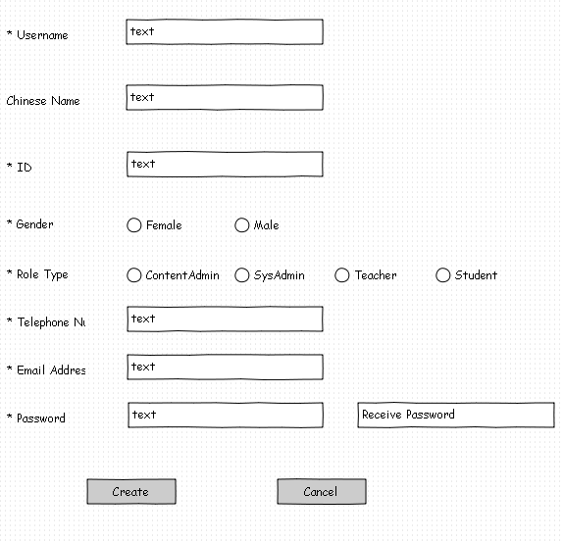
Diagram 1

General Workflow:

User Operation | System Response
1: Users use the function of creating user. | 2: Open the page just like Diagram 1.
3: Users fill the form and click Create button.
3.1: All the content with * are filled in. | 4: System will validate data. If ok,  system will save this information and return to this page with the tip of success; If not ok, system will pop up a window with the tip of error.
3.2: Not all the content with * are filled in. | 5: System will pop up a window with the tip of error.
6: Users fill the form and click Cancel button. | 7: Return to the page just like Diagram 1 with initial state.
Comment: None.
validate data
1. All the content with * must be filled in.
2. ID must be unique.
3. The telephone number and email address format must be correct.

UC002 <SysAdmin Edit User>
Brief: SysAdmin edit user

Actor: SysAdmin

Pre-condition: There is a user with SysAdmin role logged in system successfully.

Mock Up UI:
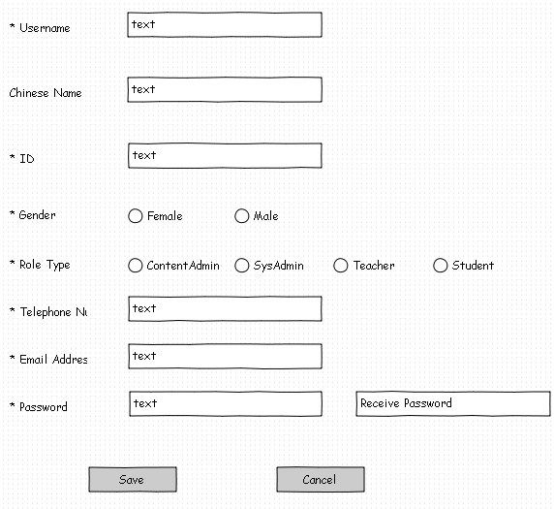
Diagram 1

General Workflow:

User Operation | System Response
1: Users use the function of editing user. | 2: Open the page just like Diagram 1 with the before information.
3: Users fill the form and click Save button.
3.1: All the content with * are filled in. | 4: System will validate data. If ok,  system will save this information and return to this page with the tip of success; If not ok, system will pop up a window with the tip of error.
3.2: Not all the content with * are filled in. | 5: System will pop up a window with the tip of error.
6: Users fill the form and click Cancel button. | 7: Return to the page just like Diagram 1 with initial state.
Comment: None.
validate data
1. All the content with * must be filled in.
2. ID must be unique.
3. The telephone number and email address format must be correct.

UC003 <SysAdmin Delete User>
Brief: SysAdmin delete user

Actor: SysAdmin

Pre-condition: There is a user with SysAdmin role logged in system successfully.

Mock Up UI:
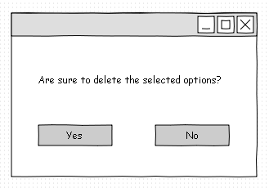
Diagram 1

General Workflow:

User Operation | System Response
1: Users use the function of deleting user. | 2: Pop up the window just like Diagram 1.
3.1: Users click Yes button. | 4: System will delete the selected data and return the query page.
3.2: Users click No button. | 5: System will return the query page.
Comment: None.
validate data
The selected data can't be the current user.

UC004 <SysAdmin View users list>
Brief: SysAdmin view users list

Actor: SysAdmin

Pre-condition: There is a user with SysAdmin role logged in system successfully.

Mock Up UI:
Diagram 1

General Workflow:

User Operation | System Response
1: Users use the function of viewing users list. | 2: Open the page just like Diagram 1.
Comment: There will be search functions.
validate data
None.

UC005 <ContentAdmin Create Question>
Brief: ContentAdmin create question

Actor: ContentAdmin

Pre-condition: There is a user with ContentAdmin role logged in system successfully.

UC006 <ContentAdmin Delete Question>
Brief: ContentAdmin delete question

Actor: ContentAdmin

Pre-condition: There is a user with ContentAdmin role logged in system successfully.

UC007 <ContentAdmin Edit Question>
Brief: ContentAdmin edit question

Actor: ContentAdmin

Pre-condition: There is a user with ContentAdmin role logged in system successfully.

UC008 <ContentAdmin View questions list>
Brief: ContentAdmin view questions list

Actor: ContentAdmin

Pre-condition: There is a user with ContentAdmin role logged in system successfully.

UC009 <ContentAdmin Create exam>
Brief: ContentAdmin create exam

Actor: ContentAdmin

Pre-condition: There is a user with ContentAdmin role logged in system successfully.

UC010 <ContentAdmin View exams list>
Brief: ContentAdmin view exams list

Actor: ContentAdmin

Pre-condition: There is a user with ContentAdmin role logged in system successfully.

UC011 <Teacher View exams list>
Brief: Teacher view exams list

Actor: Teacher

Pre-condition: There is a user with Teacher role logged in system successfully.

UC012 <Student Check exams>
Brief: Student check exams

Actor: Student

Pre-condition: There is a user with Student role logged in system successfully.

UC013 <SysAdmin Login&Logout>
Brief: SysAdmin login&logout

Actor: SysAdmin

Pre-condition: There is no user logged in system successfully

Mock Up UI:
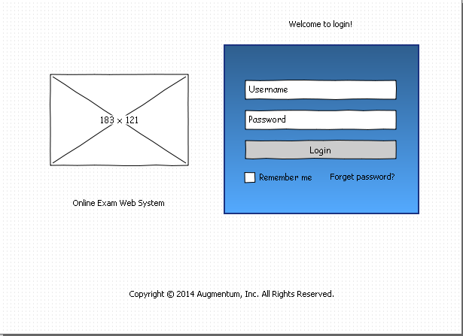
Diagram 1

General Workflow:

User Operation | System Response
1: Users write the url of login. | 2: Open the page just like Diagram 1.
3: Users click Login button.
3.1: Users don't fill username or password. | 4: System will prompt error.
3.2: Users fill username and password. | 5: System will validate data. If ok,  system will save this information and jump to welcome page; If not ok, system will prompt error.
Comment: None.
validate data
1. Determine whether the username is correct.
2. Determine whether the username matches the password.

UC014 <ContentAdmin Login&Logout>
Brief: ContentAdmin login&logout

Actor: ContentAdmin

Pre-condition: There is no user logged in system successfully

UC015 <Teacher Login&Logout>
Brief: Teacher login&logout

Actor: Teacher

Pre-condition: There is no user logged in system successfully

UC016 <Student Login&Logout>
Brief: Student login&logout

Actor: Student

Pre-condition: There is no user logged in system successfully

UC017 <SysAdmin Edit user profile>
Brief: SysAdmin edit user profile

Actor: SysAdmin

Pre-condition: There is a user with SysAdmin role logged in system successfully.

UC018 <ContentAdmin Edit user profile>
Brief: ContentAdmin edit user profile

Actor: ContentAdmin

Pre-condition: There is a user with SysAdmin role logged in system successfully.

UC019 <Teacher Edit user profile>
Brief: Teacher edit user profile

Actor: Teacher

Pre-condition: There is a user with Teacher role logged in system successfully.

UC020 <Student Edit user profile>
Brief: Student edit user profile

Actor: Student

Pre-condition: There is a user with Student role logged in system successfully.

Non-functional Requirements
Each requirement should have unique ID for cross reference purposes (NFR0001, NFR0002, etc.)

System Installation Requirements
Is there a hardware requirement?
Is there a requirement on other software components?
What does installation process look like?

Runtime Requirements
What are startup/initialization/shutdown/cleanup processes?
What are the memory requirements?
What are the disk space requirements?

Each runtime requirement should have unique ID for cross reference purposes (NFR0001, NFR0002, etc.)

I18N and L10N Requirements
Are I18N (Internationalization) and L10N (Localization) required for the system? Which languages that the system needs to support?

Documentation Requirements
What does this component require from the Technical Publication team?
Does this require a user manual, samples, reference manual, quick start guide, online help, context sensitive help, etc.?

Other Non-functional Requirement
You can add section here to describe what you think is necessary here. Such as security requirements, performance requirements, legal requirements, industry protocol/standard, etc.

